Preparation of Papers for International Journal of Engineering Research and Science
First Author¹, Second Author²
¹Department of ECE, XYZ University, NEW DELHI-46
Email: abcdef@gmail.com
²Department of Information Technology, ABC University, USA
Email: abcdef@hotmail.com
Abstract— The abstract should summarize the content of the paper. Try to keep the abstract below 250 words. Do not make references nor display equations in the abstract. The journal will be printed from the same-sized copy prepared by you. Your manuscript should be printed on A4 paper (21.0 cm x 29.7 cm). It is imperative that the margins and style described below be adhered to carefully. This will enable us to keep uniformity in the final printed copies of the Journal. Please keep in mind that the manuscript you prepare will be photographed and printed as it is received. Readability of copy is of paramount importance.
Keywords— About five key words in alphabetical order, separated by comma.

Introduction
the introduction of the paper should explain the nature of the problem, previous work, purpose, and the contribution of the paper. The contents of each section may be provided to understand easily about the paper.

Headings
The headings and subheadings, starting with "I. Introduction", appear in upper case letters and should be set in bold and aligned center. All headings from the Introduction to Acknowledgements are numbered sequentially using I, II, III, etc. Subheadings are numbered 1.1, 1.2, etc. If a subsection must be further divided, the numbers 1.1.1, 1.1.2, etc.
The font size for heading is 11 points bold face and subsections with 10 points and bold. Do not underline any of the headings, or add dashes, colons, etc.

Material and Method
It should contain your work and project.
Figures and Table should be in the below format.
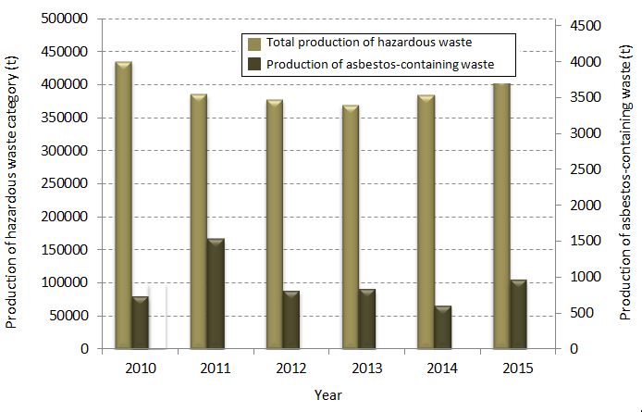
Figure 1: Production of asbestos-containing waste in years 2010 – 2015

Table 1

Comparison between Main Method
Sr. No. | Paper Name | Advantages | Disadvantages
01. | Computational Deep Intelligence Vision Sensing for  Nutrient Content Estimation in  Agricultural Automation | Use of DSELM and GA provides unmatched accuracy alongside easier functioning | Takes a lot of time to construct the database of the entire program.  Can be used only on a single object of interest, adding another Object result in Large amount of recoding.
02. | Estimation of  Nitrogen content in leaves using  Image processing | Smaller database required for functioning.  Image Pre-Processing results in a more consistent system overall. | Requires Manual entry for every action.  Requires strictly clinical environments with clean backgrounds.
03. | Preliminary research on total nitrogen  content prediction of sandalwood using the  error-in-variable models based on digital  image processing | Covers large areas and a huge number of sample sizes.  Variety of Environment sensors gives highly accurate results. | Feasibility restricted to only a sample size of >100 samples.  Definitely not cheap to justify use unless Automation or One-Time Investment is involved.

Conclusion

Acknowledgements
An acknowledgement section may be presented after the conclusion, if desired.
REFERENCES
- G. Eason, B. Noble, and I. N. Sneddon, “On certain integrals of Lipschitz-Hankel type involving products of Bessel functions,” Phil. Trans. Roy. Soc. London, vol. A247, pp. 529–551, April 1955. (references)
- J. Clerk Maxwell, A Treatise on Electricity and Magnetism, 3rd ed., vol. 2. Oxford: Clarendon, 1892, pp.68–73.
- I. S. Jacobs and C. P. Bean, “Fine particles, thin films and exchange anisotropy,” in Magnetism, vol. III, G. T. Rado and H. Suhl, Eds. New York: Academic, 1963, pp. 271–350.
- K. Elissa, “Title of paper if known,” unpublished.
- R. Nicole, “Title of paper with only first word capitalized,” J. Name Stand. Abbrev., in press.

